Web Toolkit

User Manual

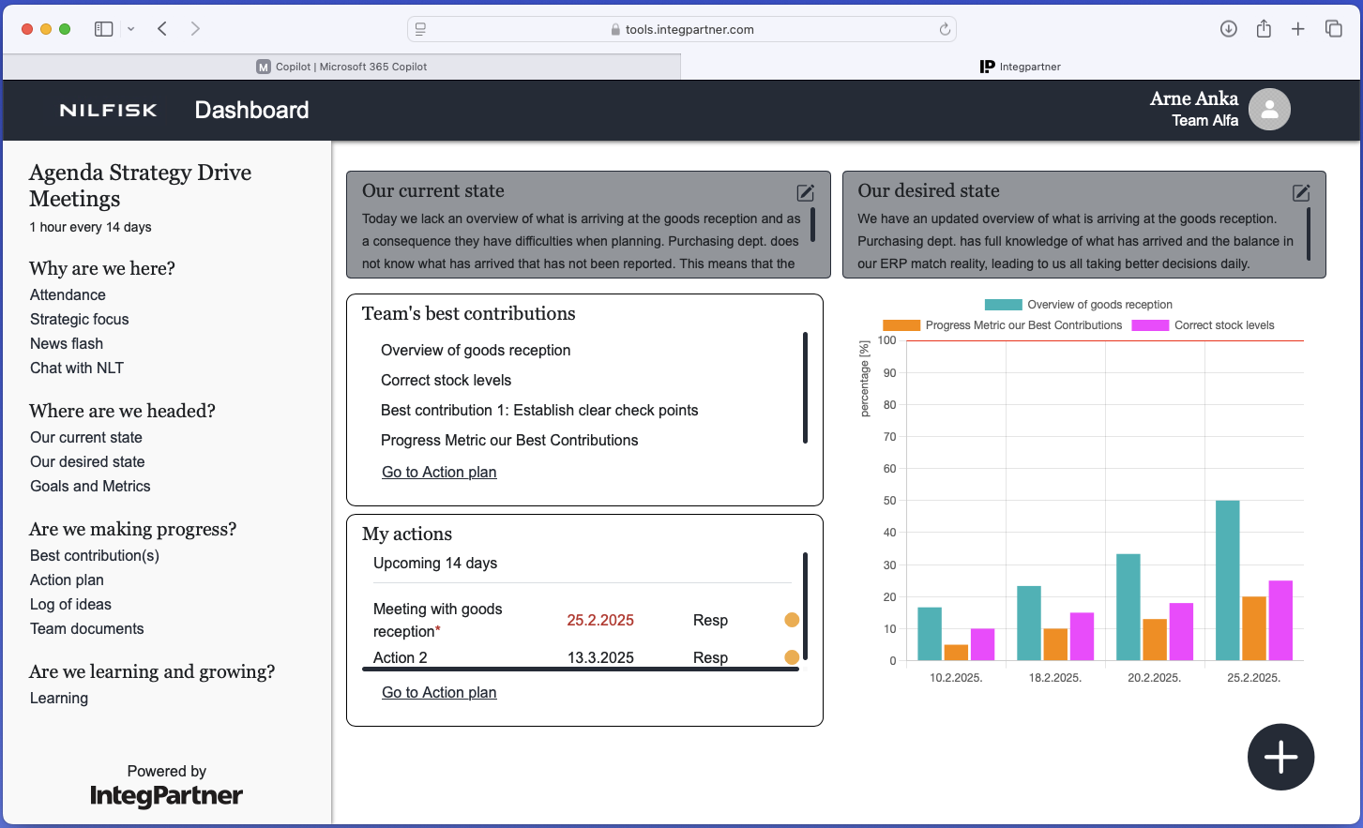
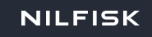


Introduction
This is the user manual for Web Toolkit, a web-based IT-solution developed by Integ Partner AB. Web Toolkit supports a way of working in an organization that is well aligned to the principles of Integral Management.

Dashboard
The Dashboard is the central part of the Web Toolkit home page. The top row features “Our current state” and “Our desired state” modules, both with edit icons leading to those modules. Below “Our desired state” module, there are “Team’s best contributions” and “My actions” sections.

“Team’s best contributions” showcases the best contributions in the action plan, with a scrollable list and a “Go to Action plan” link. “My actions” displays tasks for the logged-in user with upcoming deadlines in the next 14 days or overdue tasks. Tasks appear if the user is responsible or mentioned as support, including team-supported tasks.

Agenda Strategic Drive Meeting

The agenda is accessible through a sidebar located on the left side of the application once the user has logged in.

Attendance
Access the Attendance module by clicking "Attendance" under the "Why are we here?" section on the sidebar. This module tracks team members' meeting attendance. Users can also add notes explaining attendance.

Start new meeting
In the “Attendance” module, you can see a list of team members with checkboxes next to their names. The team lead is marked with an icon. Below the list, there is a textbox titled “Notes regarding attendance” for adding comments. The “Save attendance” button is at the bottom.

Start new meeting flow
- Select all the team members that are present on the meeting from the list of the team members
- The user can add note to the textbox regarding attendance, but it’s not mandatory
- When the user clicks on “Save attendance” button the new meeting is saved and added on the top of the meeting list
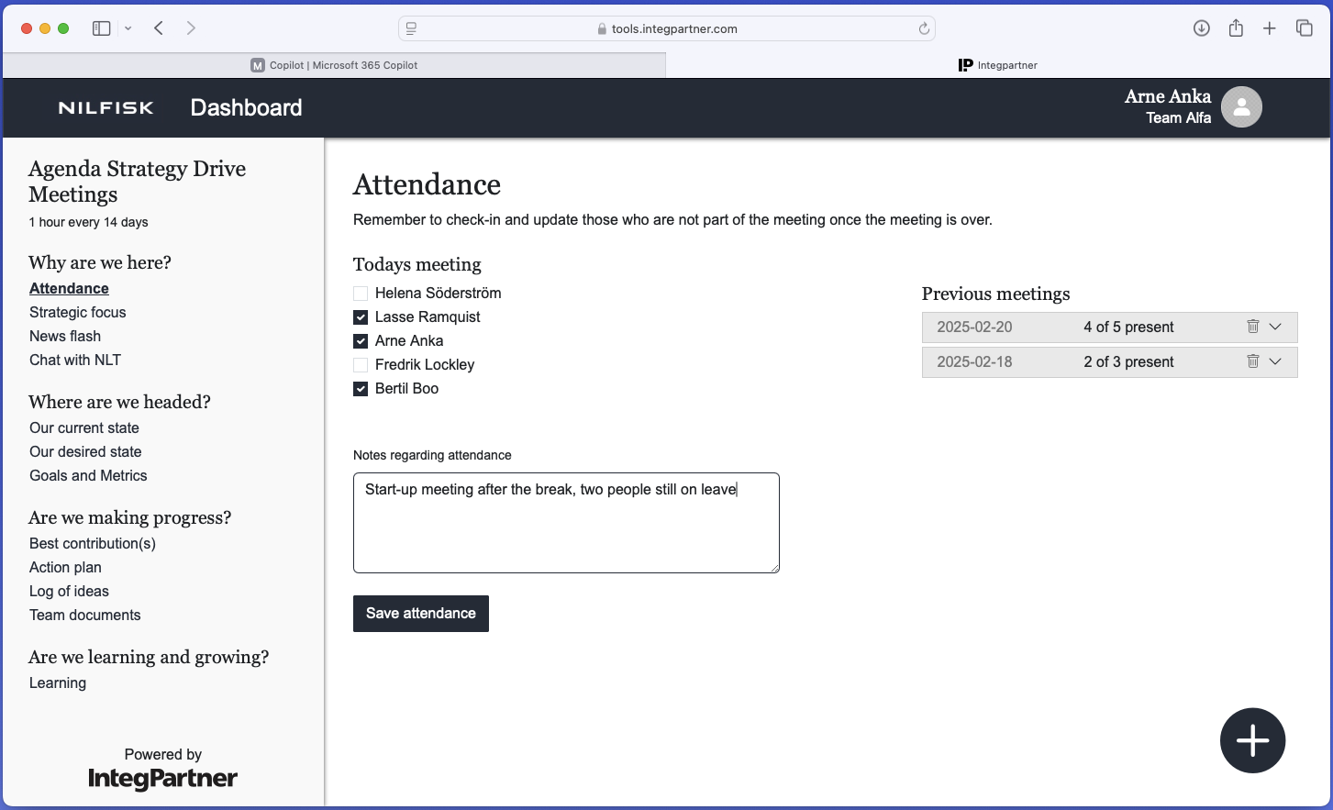

- The changes are saved, and meeting is no longer visible on the meetings list

Strategic direction / Team documents
The purpose of these modules is to share team-relevant and strategic documents and make them easily accessible to all team members.

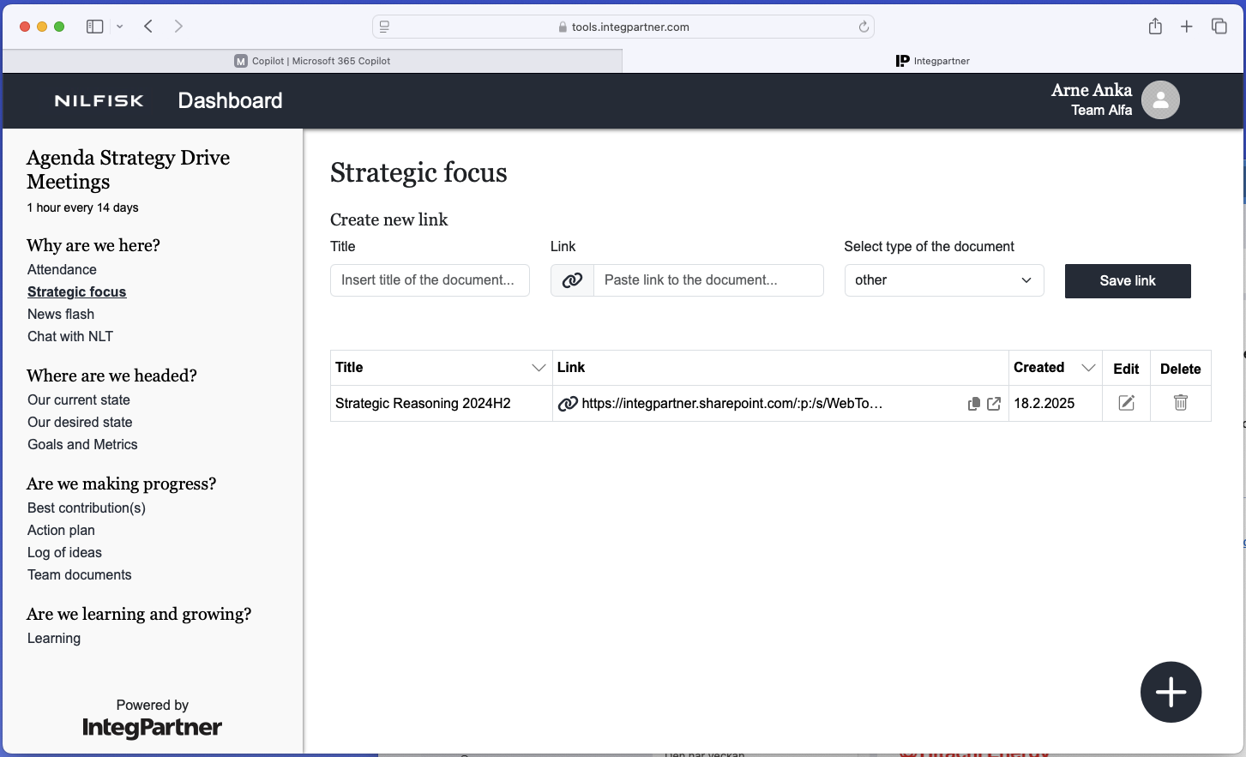

Create links
The form includes fields for the link title, URL, and a document type dropdown. A “Save link” button is on the right. Document types available are:
- Microsoft Word documents (doc or docx in the drop-down)
- PDF documents (pdf in the drop-down)
- PowerPoint documents (ppt and pptx in the drop-down)
- Excel documents (xls and xlsx in the drop-down)
- CSV document (csv in the drop-down)
- Other types of documents (other in the drop-down)

The document type is chosen automatically based on the link extension, defaulting to "other" if unsupported.
- Enter the link title, link and selects the type of the document in the form (link title and actual link are mandatory fields). Link needs to be in one of the following formats: www.url.com, https://url.com, https://www.url.com, http://url.com, http://www.url.com, url.com.

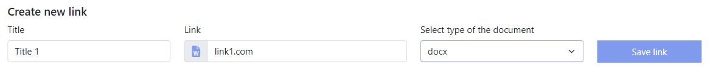

- Confirm this action by clicking on the “Save link” button

News flash/Chat with NLT
This section enables you to enter links to News flashes and other information that you want to start the meeting by sharing. There is also a link to the planned chat with NLT-functionality
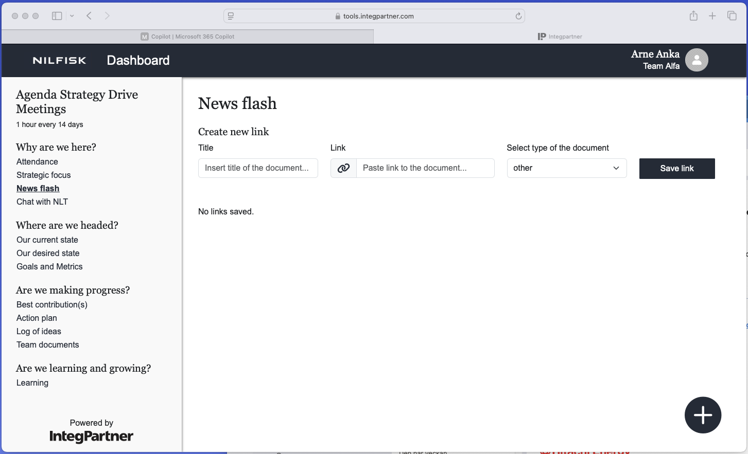

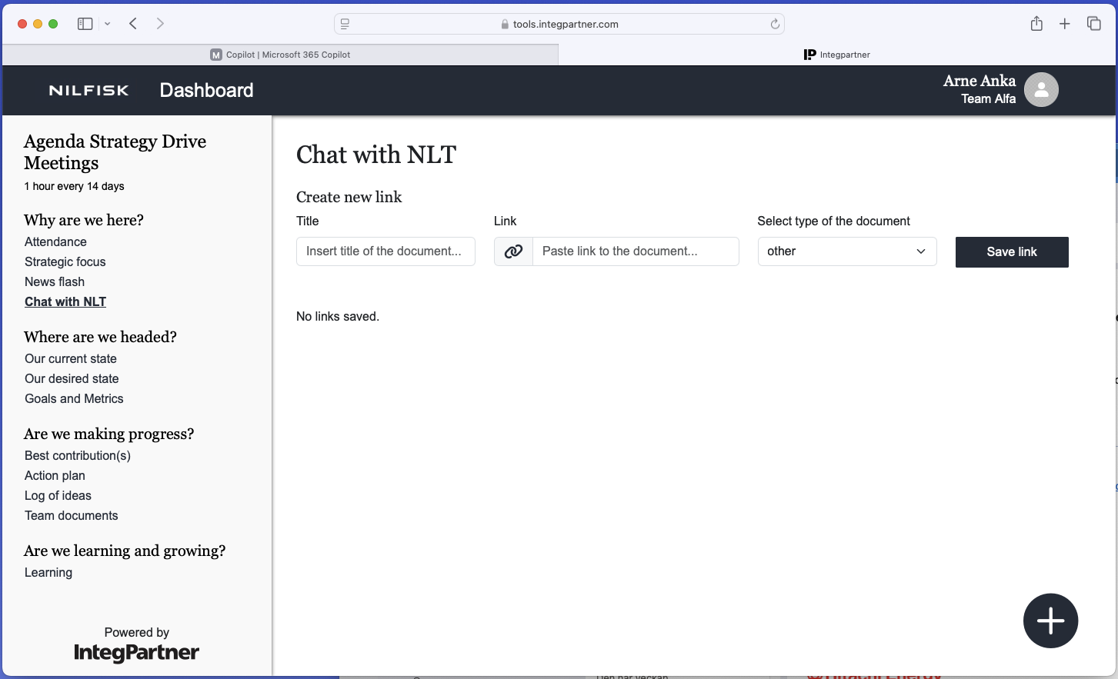

Our current state, Our desired state
The "Our current state" module is located under the “Where are we headed” This module includes a description asking, “Enter a description of how you feel that the situation is today, where to start from?” Below the description, there is a textbox and a save button.
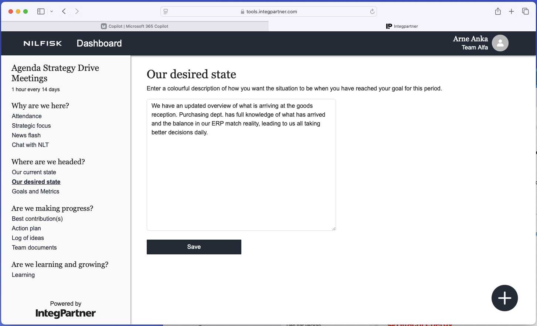
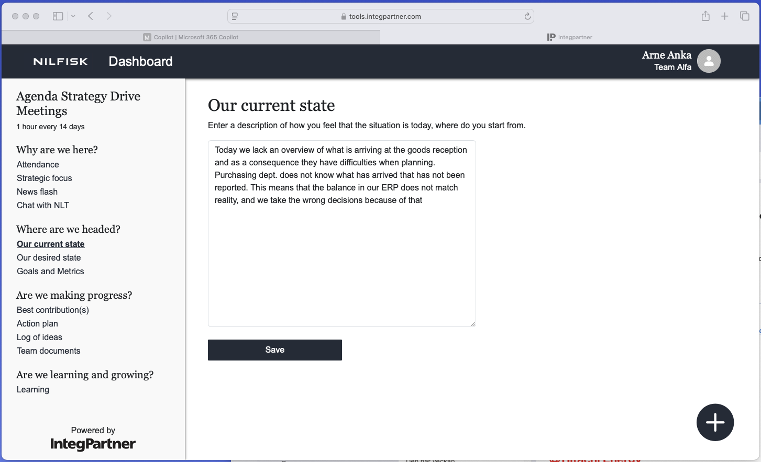

Goals and Metrics
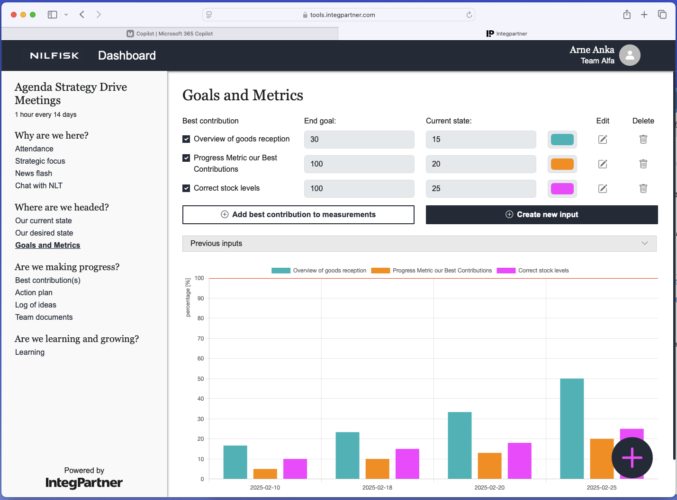
The purpose of this module is to enable tracking of end goals related to optimal contributions through visual representation in the form of graphs. Goals are tracked and updated at each new meeting. When a user accesses this module, if no best contributions have been added, an “Add best contribution to measurements” button will appear, accompanied by a message stating: “You need to add at least one best contribution before creating a new input.” If best contributions have already been added, the user will see them listed along with numerical values for the end goal and current state.

Below the list, there are “Add best contribution to measurements” and “Create new input” buttons. Additionally, a collapsible list of previous inputs is located below these buttons, and a graph is displayed at the bottom of the page.

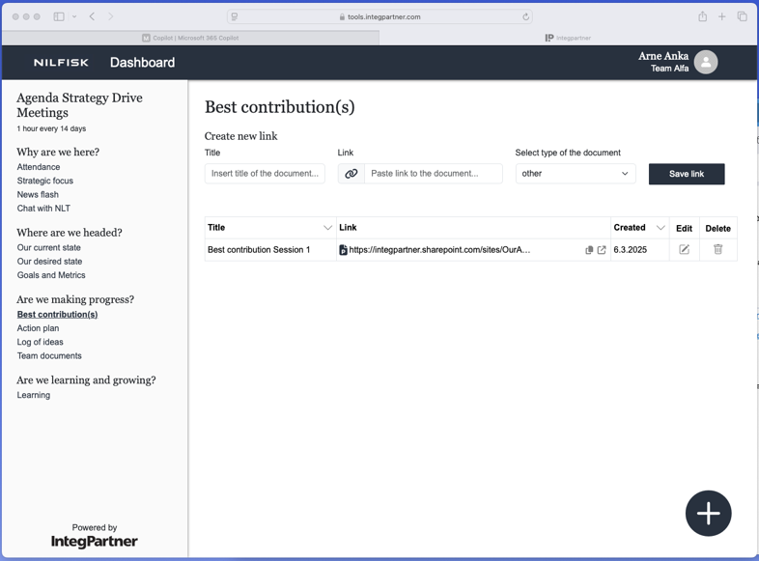
Are we making progress?
Access the action plan by clicking on the “Action plan” link in the “Are we making progress” section on the sidebar. The module includes best contributions with areas for improvement, each containing actions/tasks assigned to team members. This module provides an overview of the team's goals, progress insights, and responsibilities.

Create best contribution flow
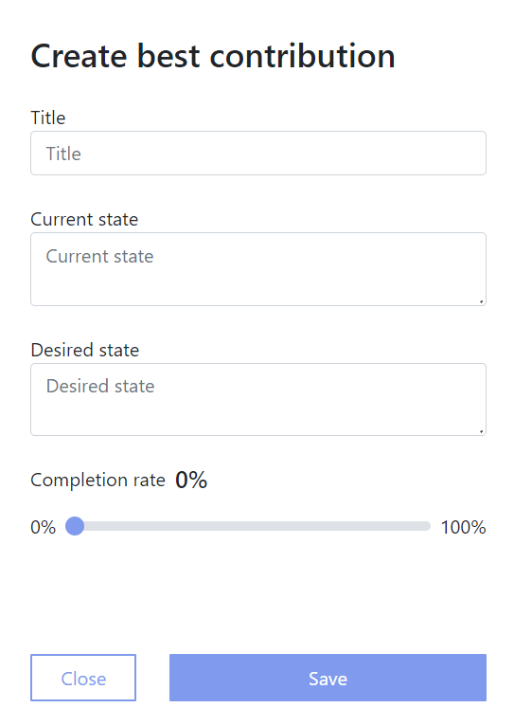
- Click on the “Add new best contribution” link on the bottom of the module below all best contributions
- A Window is shown containing following fields: title, current state, desired state and slider that indicates the completion rate of the best contribution along with the “Close” and “Save” buttons
- Input desired data (only mandatory field is best contribution title)
- Confirm this action by clicking the “Save” button
- The data is saved and newly created best contribution is visible in the list of best contributions in the action plan

When a new best contribution is created, an "No area of improvement" entry is added. These entries track actions without a specified area of improvement.

Create area of improvement
- Select “Add new area of improvement” link below the best contribution to which you want to add new area of improvement to along with the “Close” and “Save” buttons
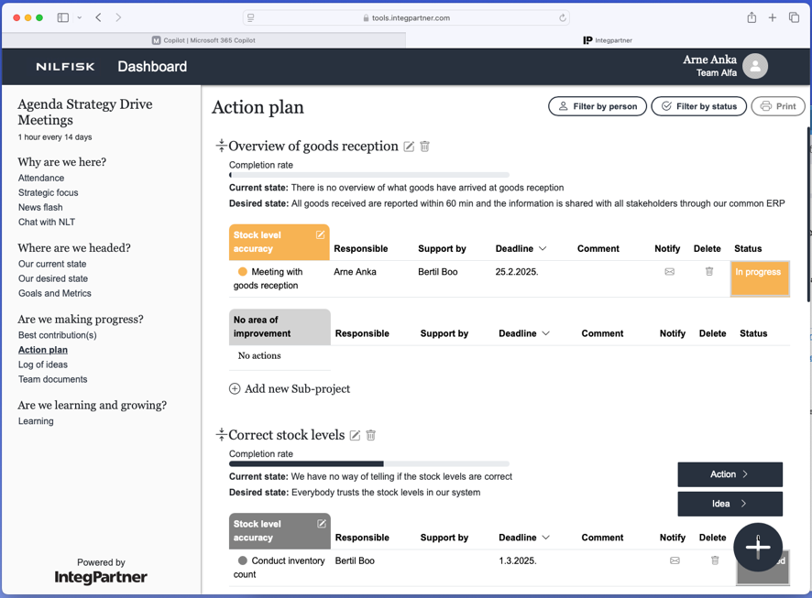

A new area for improvement is introduced, accompanied by a field for users to enter a title.
- Enter the title
- Click on the “Save” button, the changes are saved, and a new area of improvement is added and visible on the action plan

Create action flow
- Click on the big circular floating + button in the bottom right corner and two options pop up: “Action” and “Idea”

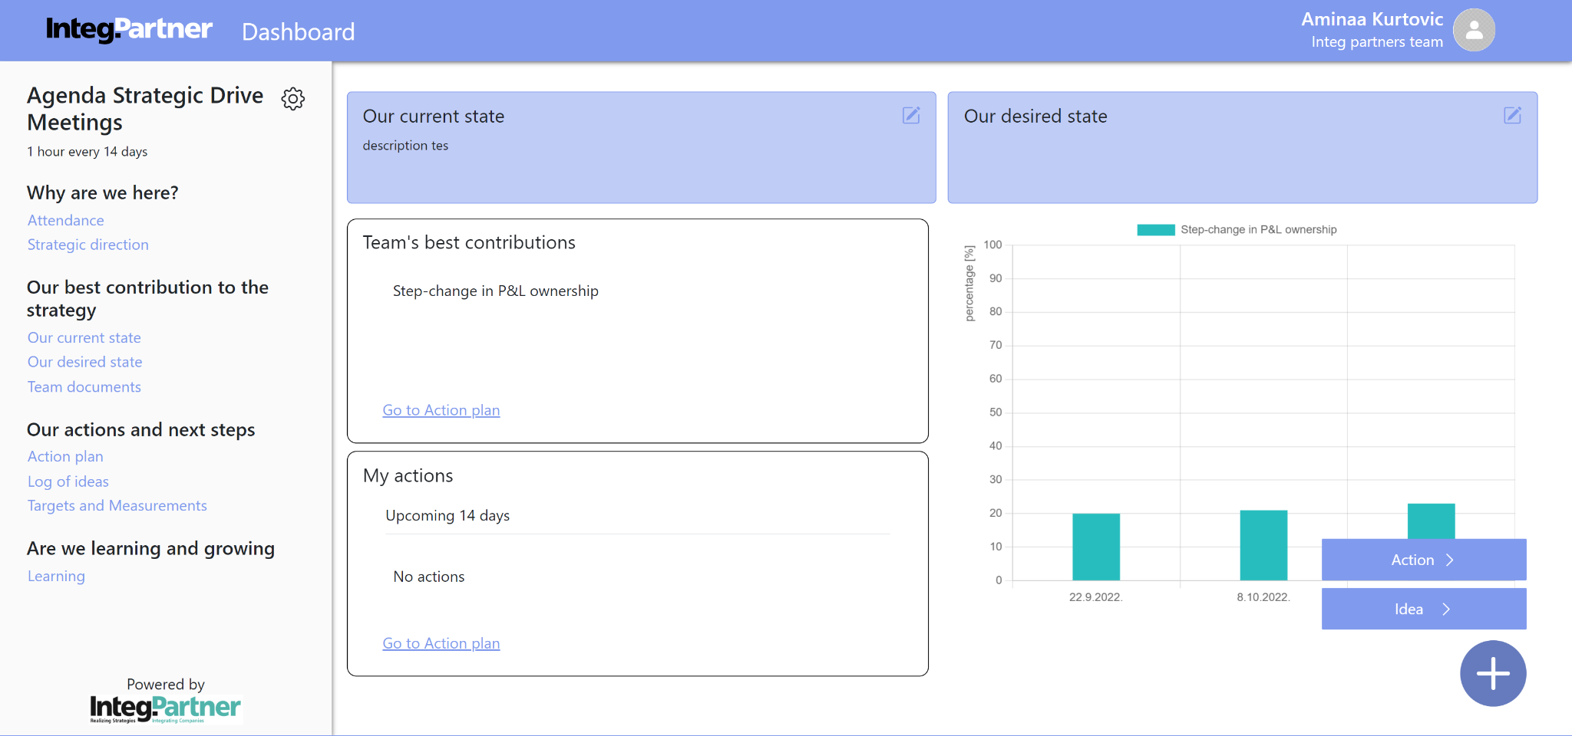

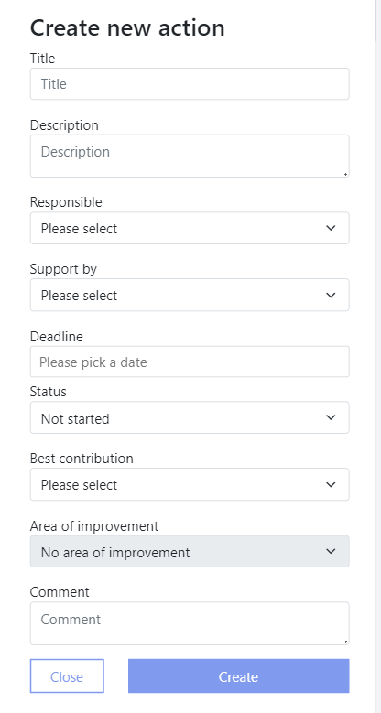
- When choosing the “Action” option a “Create new action” window is opened

- Input the data about the action (title and best contribution are the only mandatory fields)
- Confirm this action by clicking on the “Create” button
- The new action is created and visible on the action plan

When creating an Action, improvement areas are limited to those from the selected best contribution. The "Responsible" and "Support by" drop-downs list all team members.

Filters
Filter buttons are on the right side of the action plan title. Users can filter the action plan by team members (person) or status, or both simultaneously.
Clicking a filter button allows users to select an option to filter actions in the best contributions
accordingly. Areas with no respective actions remain visible.

When filtering by person, actions matching the “responsible” or “support by” columns are shown. The filter options include all team members. When filtering by status, actions matching the “status” column are displayed. Status options are: not started, in progress, delayed, and done. Filtering by both person and status displays actions where both the “responsible” or “support by” and “status” columns match the selected filters.

Filtering action plan flow
- Click on chosen filter button and the drop-down menu shows up
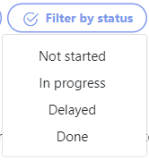
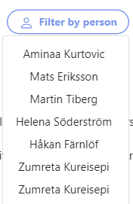

- Choose desired option, The actions in all best contributions are automatically filtered and the only ones displayed are the ones that match the filter

Log of ideas
Access the Ideas module by clicking on "Log of ideas" under "Our actions and next steps" in the sidebar. This module stores user-generated ideas that can be converted into actions to support the team's strategy. Ideas are displayed as post-its.

Create idea flow
- Click on the big circular floating + button in the bottom right corner and two options pop up: action and idea
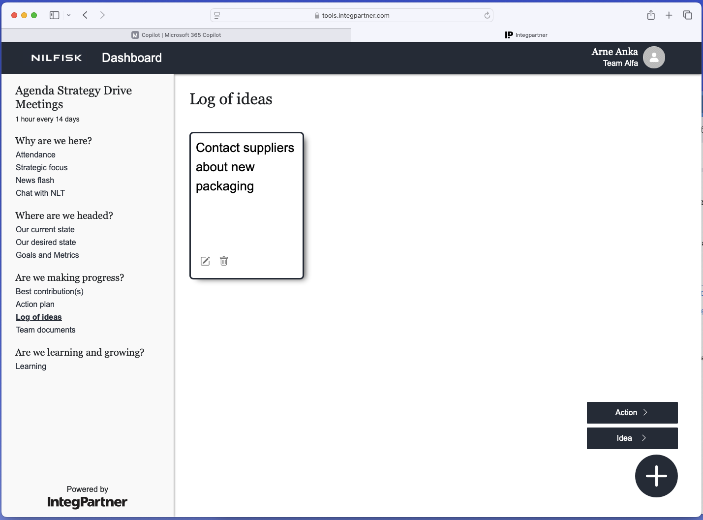

- Choose the “Idea” option and a window opens up with drop-down to choose idea module to which user wants to add new idea, title and description fields along with the “Close” and “Create” buttons
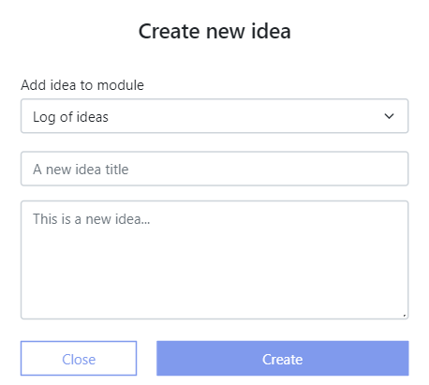

- Input desired data about the idea (title is the only mandatory field)
- Confirm this action by clicking on the “Create” button and a message pops up to notify you about successful action
- The new idea is created and visible on the idea module

Convert an idea to an action

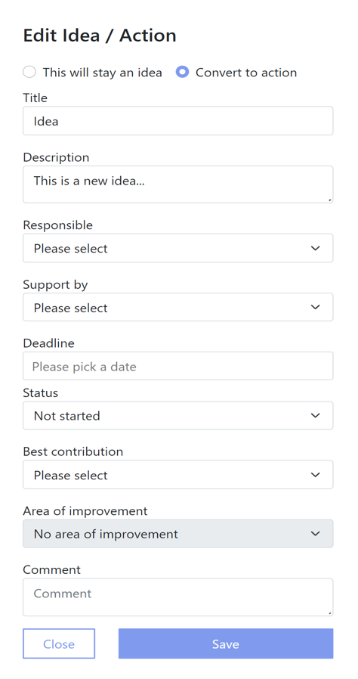
- Clicks on the edit icon in the bottom left corner of the idea that you wish to convert to action and a window opens with two tabs placed below the title: “This will stay an idea” and “Convert to action”
- Select “Convert to action” tab and following fields are visible: title, description, drop-down to choose who is responsible for the action, drop-down to choose who is supporting team member for the action, date picker to pick deadline, drop-down to choose action’s status, drop-down to choose best contribution, drop-down to choose area of improvement, comment field along with the “Close” and “Save” buttons
- Enter the desired data about the action (title and best contribution are mandatory fields)
- Confirm this action by clicking on the “Create” button
- The new action is created and it’s now visible on the action plan paired with the best contribution

When converting an idea to action, improvements should focus on the selected best contribution. The dropdowns for "Responsible" and "Support" will list all team members.

Add best contributions to track future measurements

Users can add pre-existing best contributions to the targets and measurements module. They can track end goals, current states, and progress over time. End goals are represented numerically.

Add best contributions to track future measurements flow
When the user clicks “Add best contribution to measurements,” a window appears with a drop-down list of all unadded best contributions from the action plan, an end goal field, a color picker for graph representation, and "Close" and "Save" buttons.

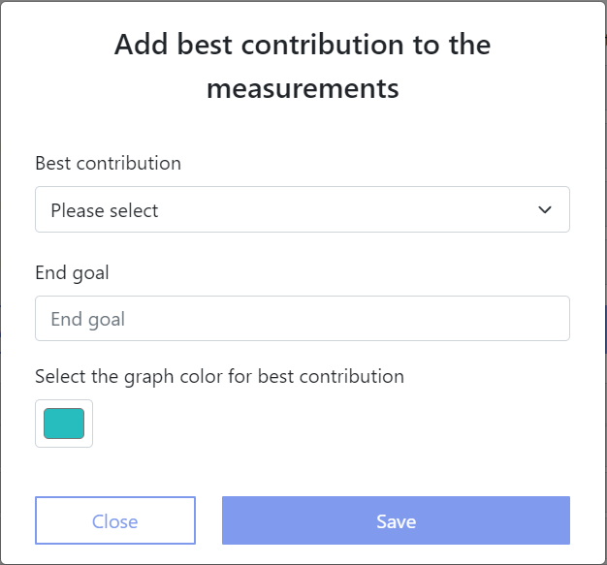

- Enter desired data (both best contribution and end goal are mandatory fields)
- Confirm this action by clicking on the “Save” button and the window automatically closes
- The new best contribution is added and is visible on the targets and measurements module

Create new input
Users can create new input for any contributions they have added to the module. Inputs are typically created approximately every 14 days, as meetings are usually held within that time frame.

Create new input flow
- Click on the “Create new input” button and window opens up with date picker to select date for inputs, list of best contributions with their respective “end goal” and “previous state” read-only fields and “current state” field.

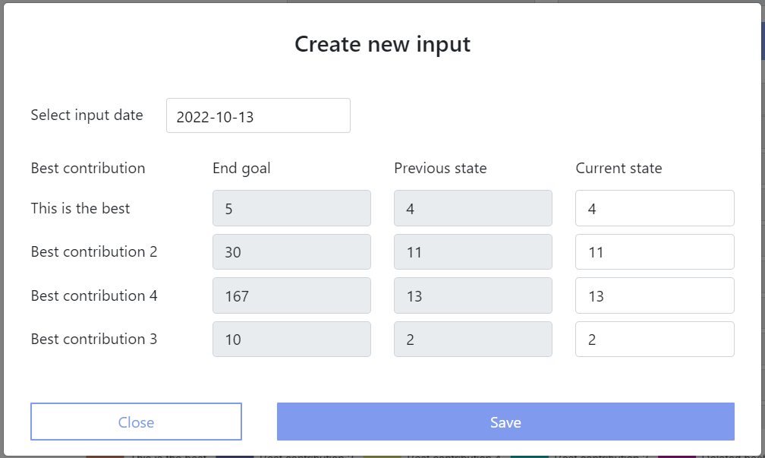
- Enter new data into “current state” fields for best contributions
- Confirm this action by clicking on the “Save” button and window closes
- Changes are saved and they are visible on the best contributions list and graph (previous state and current state of best contribution are updated which is visible if you open the “Create new input” form again)

Previous inputs overview
Previous inputs are below the list of best contributions and the buttons “Add best contribution to measurements” and “Create new input”. The list of previous inputs is initially collapsed. To expand it, click the down arrow next to the “Previous inputs” title. Once expanded, all inputs are visible, marked by date, with options to delete or expand them. The most recent inputs appear at the top. Expanding an input shows the best contributions tracked at that time, including their end goal, previous state, and current state. Multiple inputs can be expanded simultaneously. To collapse them, click the up arrow.

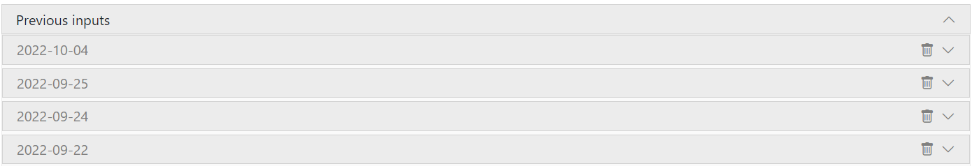

Graph overview of previous inputs
Each best contribution has a checkbox for selection. Selected contributions will be included in the graph. If only one is selected, y-axis values reflect the end goal value; if multiple, they are shown as percentages. The top of the graph displays selected contributions and their colors.

The x-axis shows meeting dates and tracked contributions. Hovering over a bar reveals details such as input date, title, value, percentage, and end goal. Deleted contributions will display "Deleted best contribution" along with relevant info.

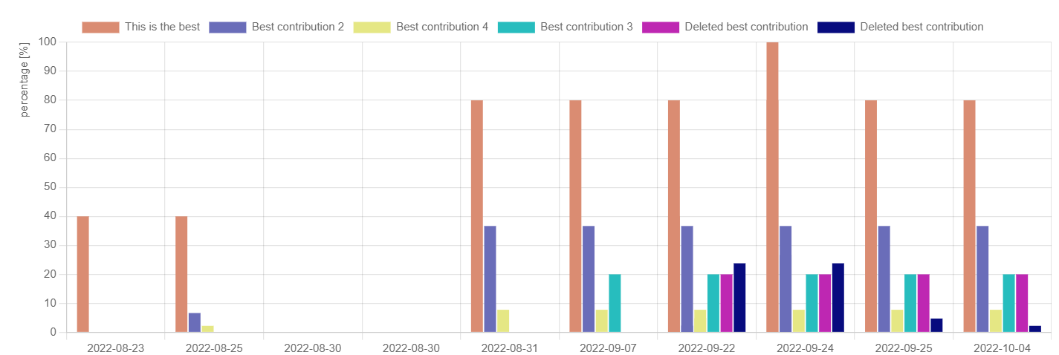

Add new action/idea floating button

The floating button for adding a new action or idea is visible throughout the application, except when admins are editing the agenda or accessing administrator panels. Located in the bottom right corner, it allows users to add either an "Action" or an "Idea" by clicking on it. The relevant window will then open for the selected option. The processes for creating new actions and ideas are described above.

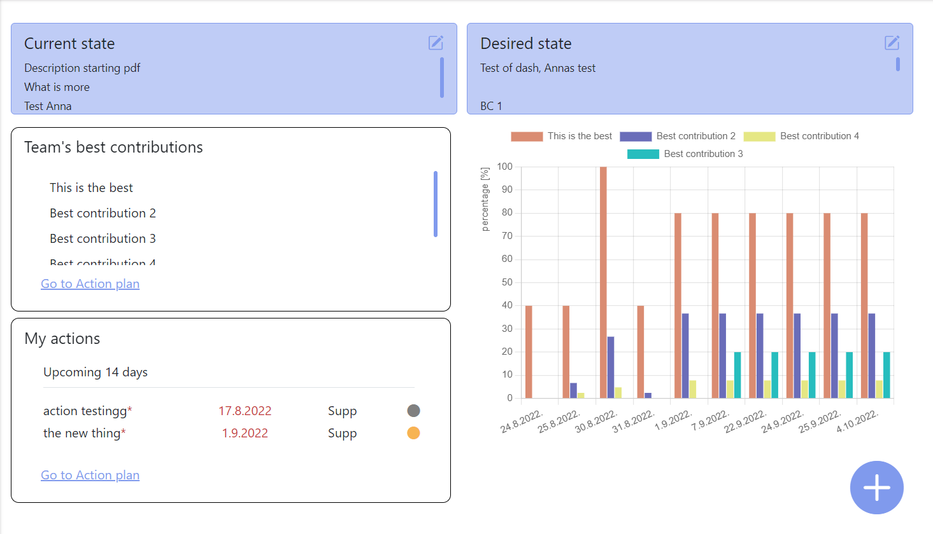

Switch language
Users are able to switch between two languages: English and Swedish.

Switch language
- Click on your name in the upper right corner and drop-down menu shows up

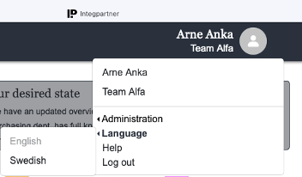

- Selects “Language” option and “English” and “Swedish” options become available
- Select the desired language, page content is now translated to the selected language

Help
To request help, users can email the IntegPartner team. Click your name in the upper right corner, select "Help" from the drop-down menu, and a mailer will open with your email in the "from" field and support@tools.integpartner.com in the "to" field. You can then send an email to request assistance.

